How to prevent a dashboard page from automatically running before the user enters a value in the prompt | 

Yoel Kortick
Senior Librarian

Question
I have created a dashboard which has a page with a prompt for “Library Name” and a prompt for “Loan Year”. When the user opens the dashboard and goes to this page the report automatically runs before the user chooses a value. How can I make the user have to choose a value before seeing any results on the page?

Answer

Note: In addition to this answer you may wish to also see “How To” document about making default values in the prompts here.

Before we give the solution, let’s see what happens now (before we make a change). When the user opens the dashboard “The fulfillment and fines and fees dashboard” and views the page “Number of Loans” all libraries are chosen, and all years are chosen. The user can then choose specific values and click “Apply” so that the report on the dashboard page will run again with desired prompt values.

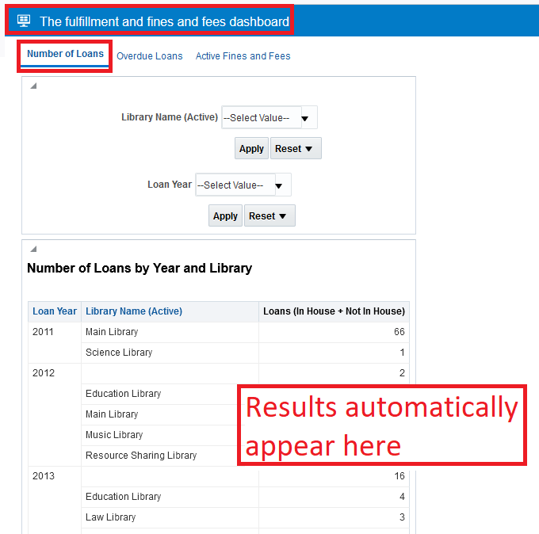

ONE
Edit the dashboard. Either here from the “catalog”…

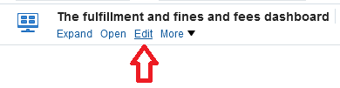

Or here while viewing the dashboard:

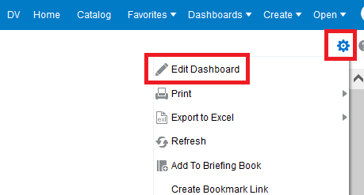

TWO
Go to dashboard properties:

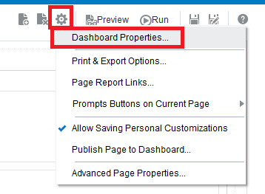

THREE
For the desired page (in our case “Number of Loans”) select the box “Prompt before Opening” and click “OK”

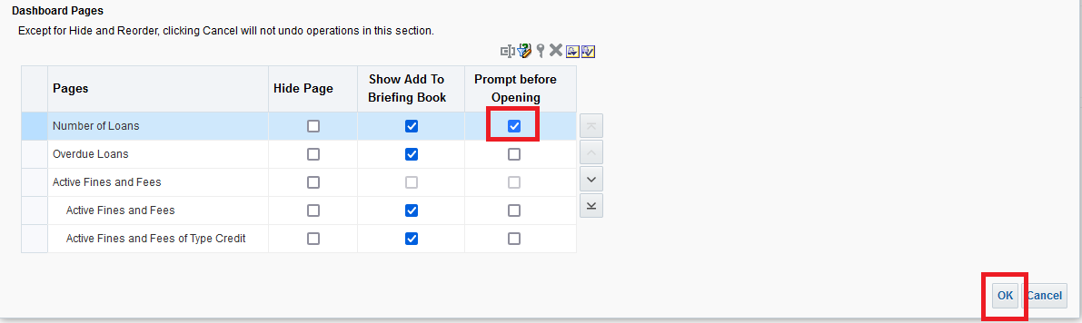

FOUR

Run the report again and see that the user receives a message “… Select prompt values and click Continue if you want to open this page”.

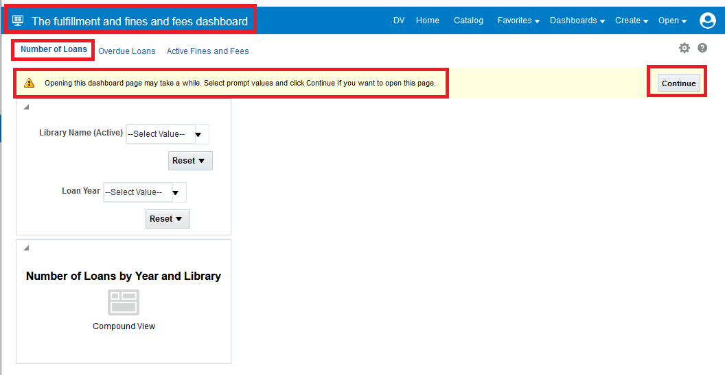

The user can then (as in the screenshot below) select desired values in the prompts and then click “Continue”.

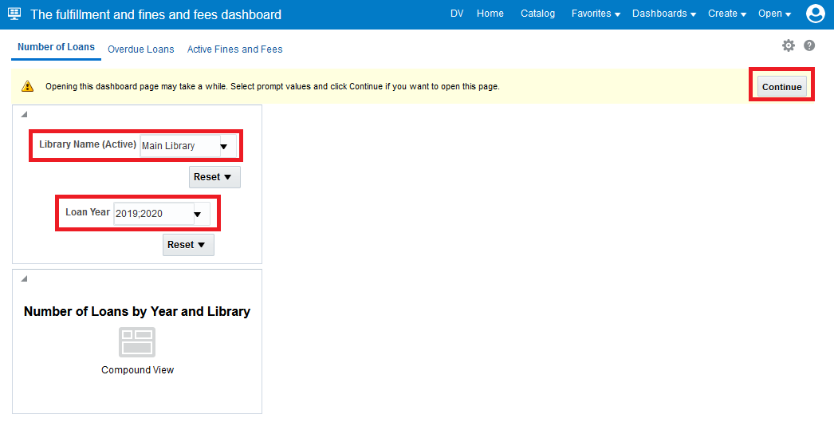

And then results appear according to values chosen in the prompt(s):

